John of Gaunt Infant and Nursery School
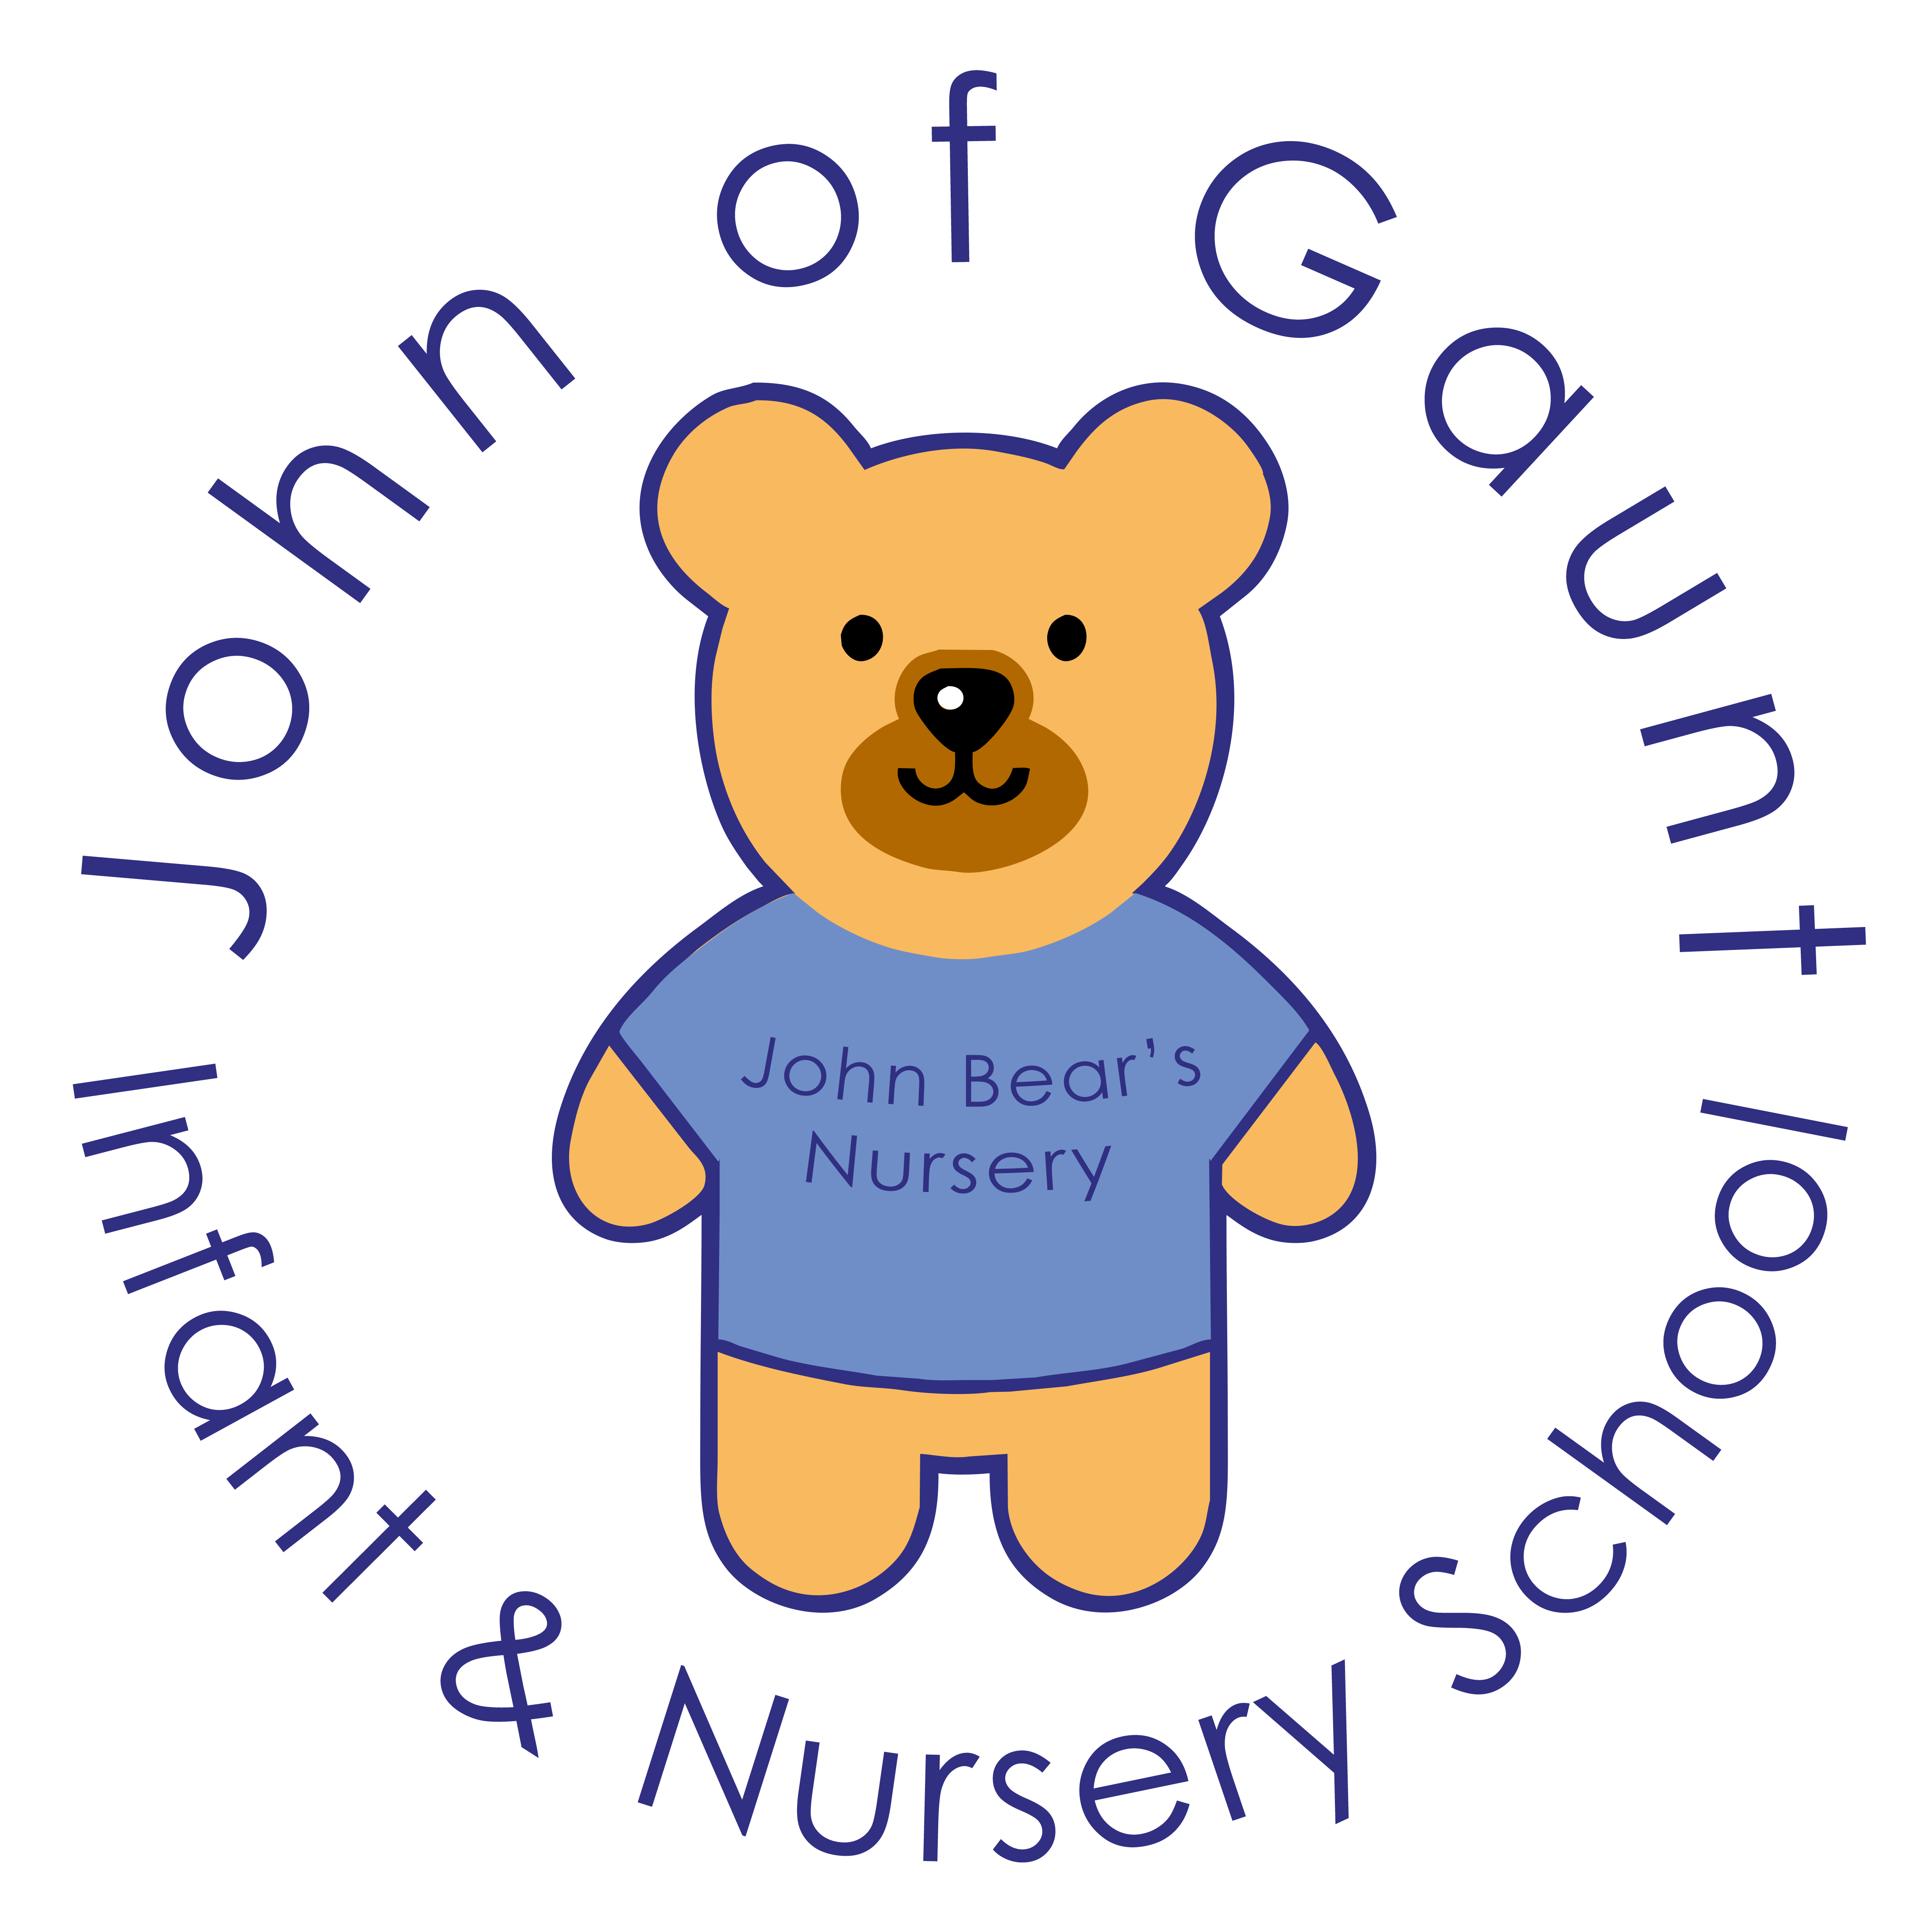
Breakfast and Tea Club Policy

Introduction
Our breakfast and tea club exists to provide high quality out-of-school hours childcare for our parents. It provides a range of stimulating and creative activities in a safe environment, within the ethos of creating a safe, secure and happy environment for our children. The clubs are run by our nursery staff.
The breakfast club operates from 7.30am – 8.45 am during term time
The tea club operates from 3.15pm – 4.30 pm and 4.30pm - 6.00pm during term time
A copy of this policy is provided to all parents of children attending the club and is also available on the school website.
All parents must sign an agreement to adhere to the terms of this policy.
Admissions
- Only children attending John of Gaunt Infant and Nursery School are eligible to attend
- All places are subject to availability
- Children’s attendance is recorded in a register
Arrival and Departure
Breakfast Club
- Parents/Carers are required to bring their child directly to John Bear’s Nursery
- Breakfast club opens at 7.30 am
- Children will be escorted to the school at 8.45am by the nursery staff and will be waited with in their respective playground until the teacher arrives to take them in to school
Tea Club
- Children in Reception, Year 1 and Year 2 will be collected by a member of staff from their classrooms and walked to the nursery
- A register is taken on arrival at tea club and handover between staff for any messages to pass on to home
Departure
- Children must be collected directly from the nursery at the end of the tea club session
- The time that the child was collected is recorded on the register
- Parents must inform the school or the nursery if someone else is collecting their child from club otherwise a phone call will be made to the parents to check

Terms and Conditions
- Children have a choice of breakfasts, snacks and tea. Children staying until 4.30pm will be offered a snack around 3.45pm and those staying until 6.00pm will have a light tea around 5pm
- Drop off and pick up times can vary according to parent’s schedules. However, sessions must be paid for in full no matter what time you drop off or pick up
- There are limited spaces available and they are allocated on a first come first served basis
- Ideally sessions will be booked a half term in advance but we are able to take ad hoc bookings as well as long as there is space and ideally these should be booked 24 hours in advance
- Bookings can be made at short notice by telephone but are subject to availability. Please do not send emails requesting breakfast and tea club
- Cancellations or amendments must be made 48 hours in advance. Cancellations after this time will still be charged for.
- Children attending an after school club can be taken to tea club 2 and will not be charged for tea club 1
Behaviour
We expect children to behave at breakfast and tea club as they would if they were at school. Whilst at the club children are expected to follow the school rules and ethos. The school behaviour policy applies at all time, including rewards and sanctions.
First Aid
Every precaution is taken to ensure the safety of the children in our care. If a child has a minor injury whilst in our care, then first aid will be carried out within the club. An injury will result in an accident form being completed and parents will be informed on collection. All club staff are first aid trained.
If a child becomes unwell during the club, parents will be contacted.
Payment of Fees
- Invoices are sent out on a half termly basis at the start of each half term
- Invoices can be paid via bank transfer, cash or cheque made payable to John Bear’s Nursery.
- If an invoice is not paid by 2 weeks in to the next half term then the club will not be able to be used until the invoice has been paid
- We are able to accept most childcare vouchers
Late Collection
Please notify tea club by ringing the nursery if you are not able to pick your child up on time. We appreciate that there will be the occasional unavoidable emergency however should this begin to happen more frequently you will be charged accordingly.
- If a child is not collected from tea club 1 on time then a 5 minute leeway will be given before the charge of tea club 2 is added to your invoice
- If a child is not collected from tea club 2 on time then a 5 minute leeway will be given. After 6.05pm a charge of £1 per minute per child will be added to your invoice
Please remember that late collection has a significant effect on staffing. Two members of staff are required to wait with your child and this is why we need to add an additional charge on.

John of Gaunt Infant and Nursery School
Breakfast and Tea Club Agreement

I…………………………………………..(Print Name) parent/carer of …………………………………… have read and accept a copy of the club policy and agree to abide by the terms therein. The sessions in this contract are 7.30am – 8.45am for breakfast club, 3.15pm – 4.30pm for tea club 1 and 4.30pm – 6.00pm for tea club 2. Sessions are booked on a first come, first served basis.

- I accept that I am the ‘contracting parent’ for the above child and agree to make payments after I receive my invoice. I understand that I will lose my place if my account is in arrears
- I understand that I must give at least 48 hours’ notice to cancel or make amendments to my booking otherwise I will still be charged for my booked sessions
- I understand that fees may change without this policy being re-issued but that significant notice will always be given for an increase in fees. The latest price schedule will be available on the school website or via either office
- I understand that a fee will be applied for late collection either after 4.35pm when tea club 2 charge will be added to the invoice or 6.05 pm onwards a £1 per minute per child will be added to my invoice
- I agree to the club staff having access to my child’s data collection sheet
- I agree to keep all contact, medical, dietary and other information up to date with the office, as I understand this will be used by the clubs

Nominated individuals authorised to collect your child

Please provide on the list below the full names of all individuals authorised to collect your child from tea club, including parents and carers. I understand that the club will not release my child to anyone else without first phoning to get authorisation.

Name Relationship to child

